Anova Test

1. Consider the dataset PlantGrowth in the given folder. The following are the details of the dataset:

The PlantGrowth is data frame of 30 cases on 2 variables.

This data frame contains the following columns:

Weight – Numeric

Group- Factor

* Do the following with the dataset
* Test whether the mean is significantly different for all the three groups (to be done on dataset PlantGrowth) using ANOVA
* Generate the following graph for the dataset

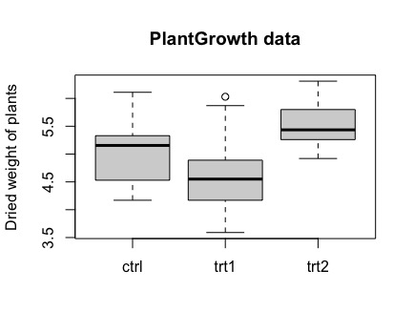

1. Consider the dataset Morley in the given folder. The following are the details of the dataset:

The Morley is data of 100 observation with 3 variables.

This data contains the following columns:

Expt – The experiment number 1 to 5

Run- run number within each experiment

Speed –Speed of light measurement

Do the following with the dataset

* Use ANOVA test on the data for numeric variable Speed for different experiments
* Generate the following graph for the dataset.

